USE CASE 4：Publish goods

|  |
| --- |
| USE CASE 4：Publish goods |
| **Related Requirements:** REQ1, REQ2, REQ3  **Initiating Actor:** User(lessor)  **Actor’s Goal:** Want to rent their own products on this platform **Participating Actors:** User(lessor), Smart Phone  **Preconditions:** Support from the system, goods can be reviewed in the background and can be stored in the database.  **Postconditions:** Provide product information feedback.  **Flow of Events for Main Success Scenario:**  *→*User provides product information to system in the product release interface  *←*Provide product information entry interface  *←*User input product information  *←*Waiting for background check  *←*examination passed, and product successfully published  **Flow of Events for Extensions (Alternate Scenarios):**  *→*User provides login request to software  *←*Provide user registration interface  *→*User created credentials  *→*User provides login request to software  *←*Provide user registration interface  *→*User created credentials |
| *→*User provides product information to system  *←*Provide product information entry interface  *←*User input product information  *←*Waiting for background check  *←*The review failed and the release of the item was illegal  *←*Return to the product release interface and feed back to the user |

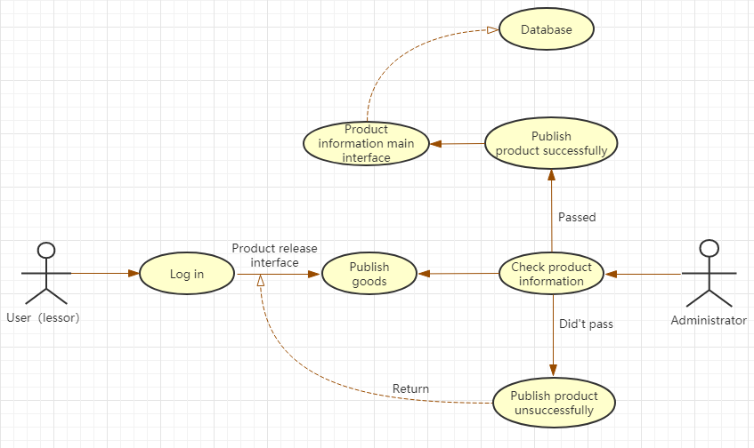

Uploading a product is a very important part for the user（lessor）. The user first has to log in to the website, enter the product release interface, and then publish the product, waiting for the background administrator to check. If the check is passed, the product information will be displayed on the homepage of the website. If the check fails, the system will return to the product release interface and feedback to the user（lessor）.

USE CASE 5：Delete **/**Modify product

|  |
| --- |
| USE CASE 5*：*Delete**/**Modify product |
| **Related Requirements:** REQ1, REQ6  **Initiating Actor:** User(lessor)  **Actor’s Goal:** Want to delete his own published product  **Participating Actors:** User(lessor), Smart Phone  **Preconditions:** This feature is available in the system  **Postconditions:** Provide information feedback.  **Flow of Events for Main Success Scenario:**  *→*User requests to enter personal product information management interface  *←*Provide user personal product information  *←*User selects the product and clicks delete  *←*Delete product information successfully |

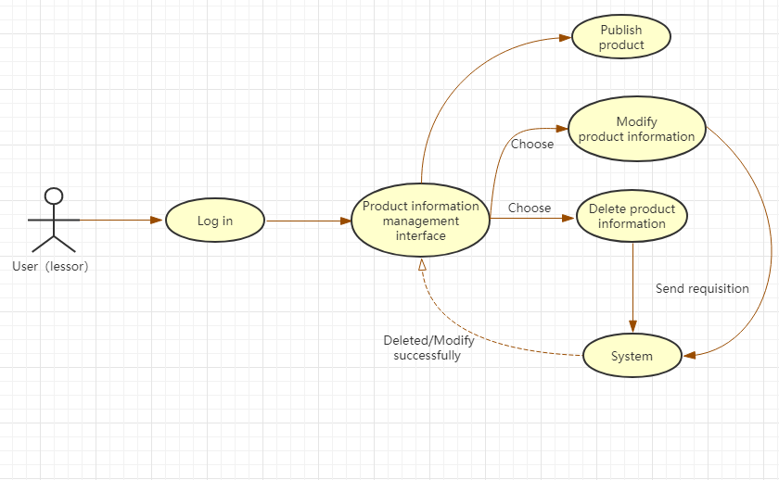

If the user（lessor） wants to delete the published item, we use this use case to achieve. First, the user（lessor） logs in to the website, enters the product information management interface, selects the product information that you want to delete and clicks “Delete”, sends the request to the system, and finally deletes successfully, and feedback to the product information management interface. Modifying the product is also similar to this process.